ASSINGMENT 11.5 ROLL NO. 2403A54112

TASK 1

SMART CONTACT MANAGER

PROMPT: Create a Python program called **"Smart Contact Manager"**

CODE:

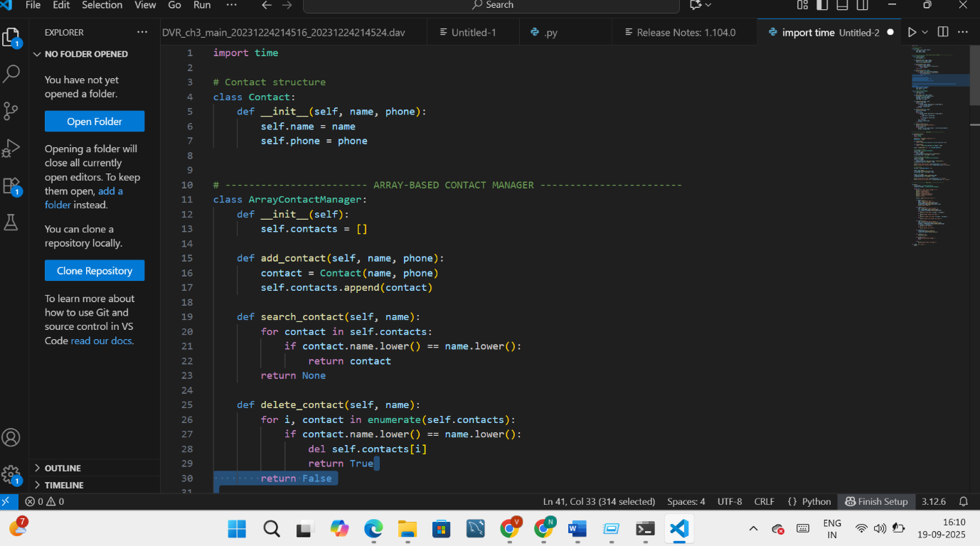

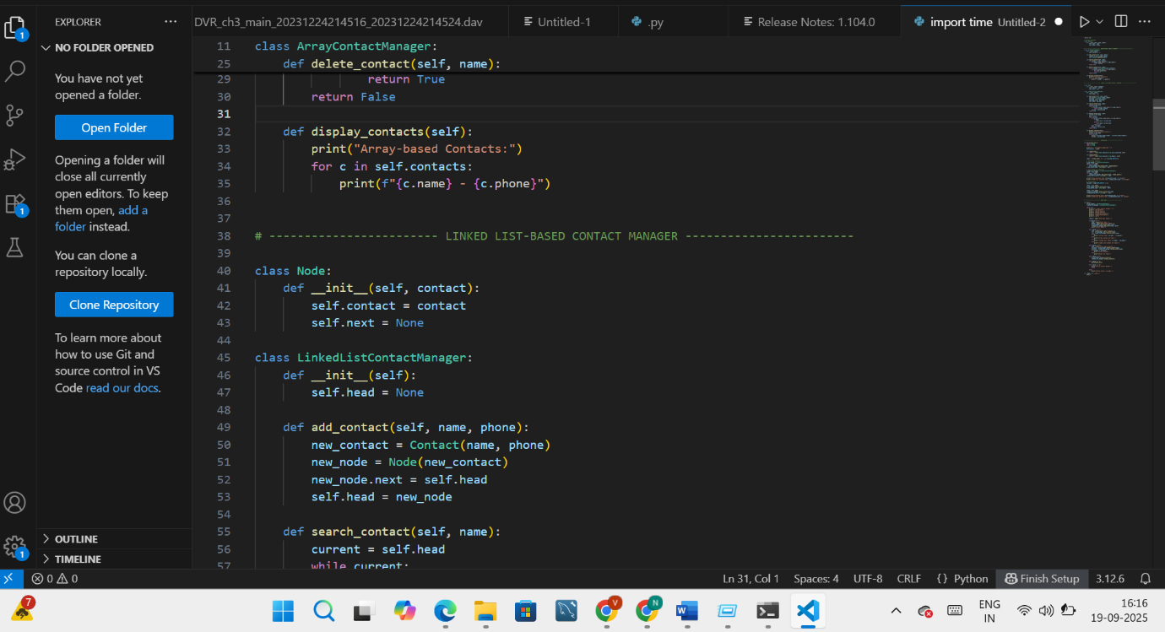

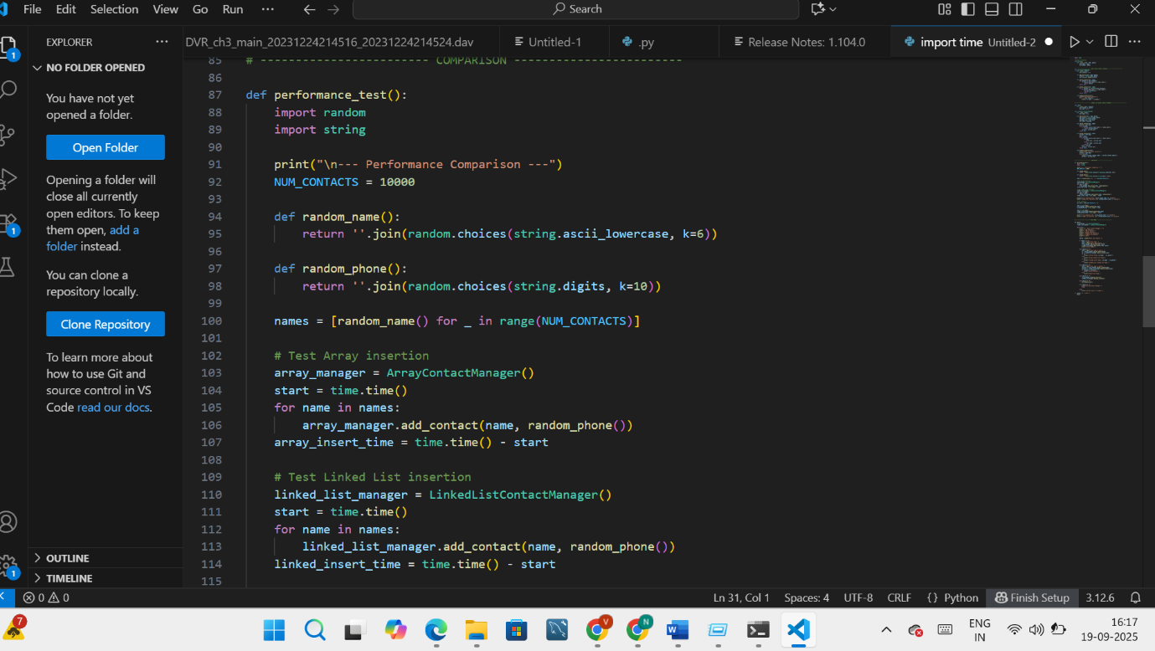

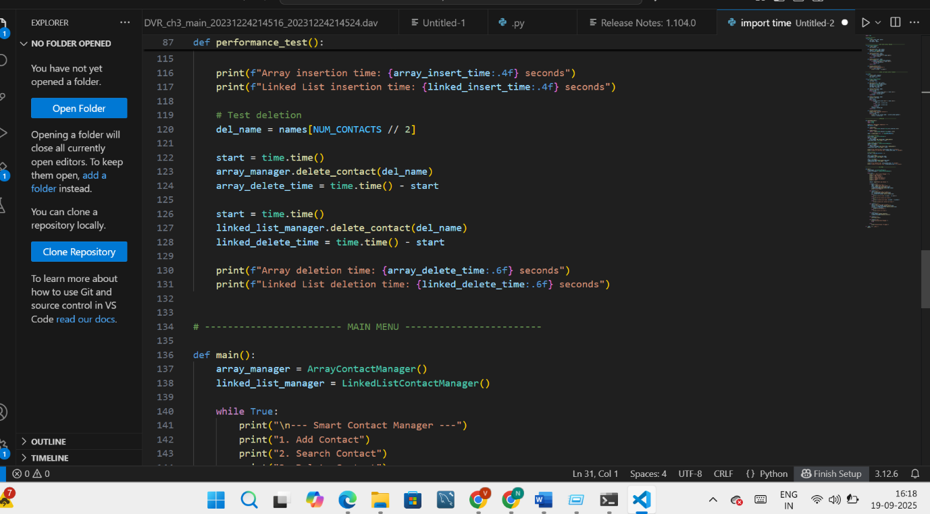

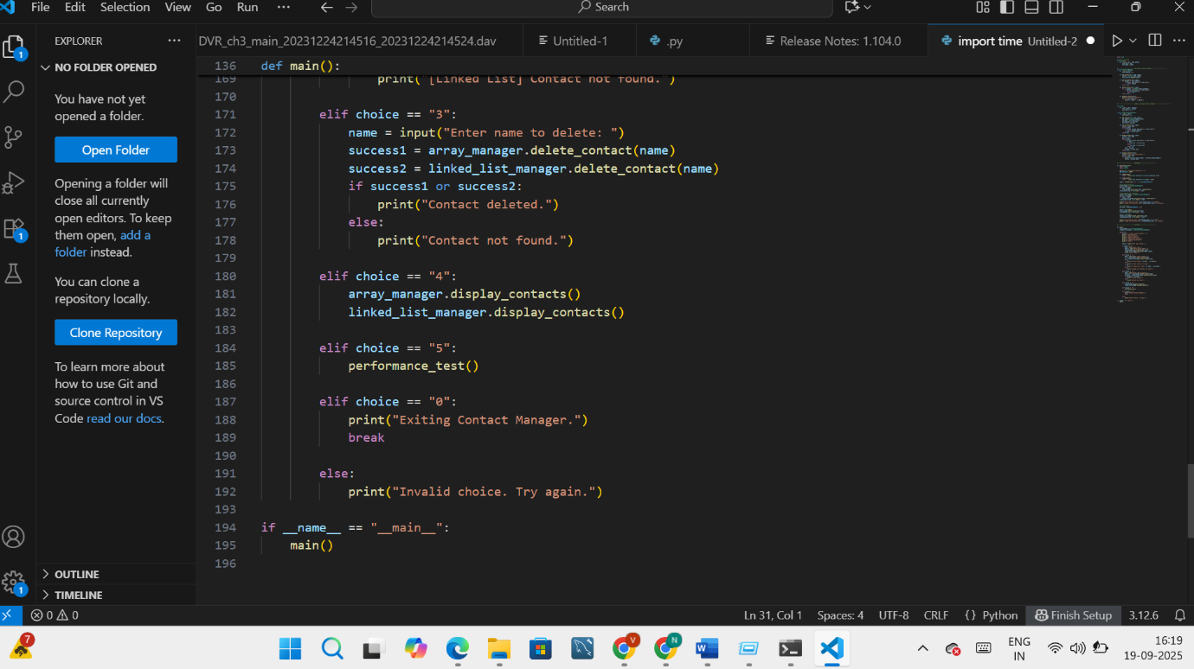

OUTPUT:

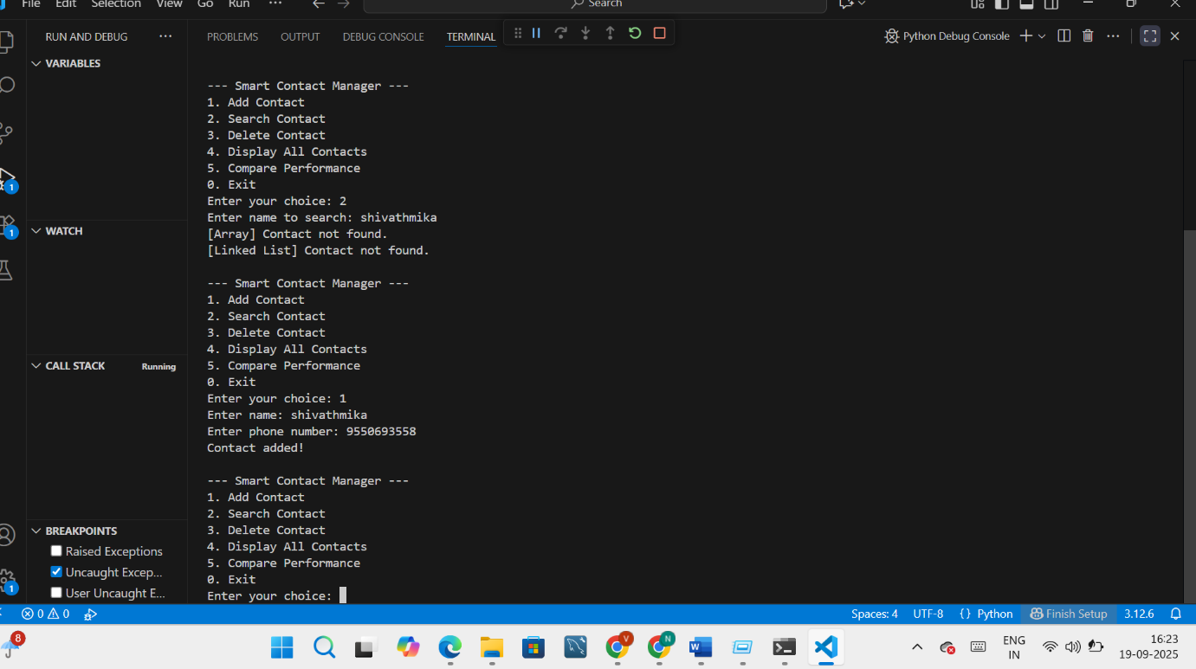

TASK-2

PROMPT:

Build a Python program to simulate an Emergency Help Desk system using a stack data structure. The stack should manage support tickets submitted by 5 members. Each ticket must include a ticket ID, member name, issue description, and priority level.

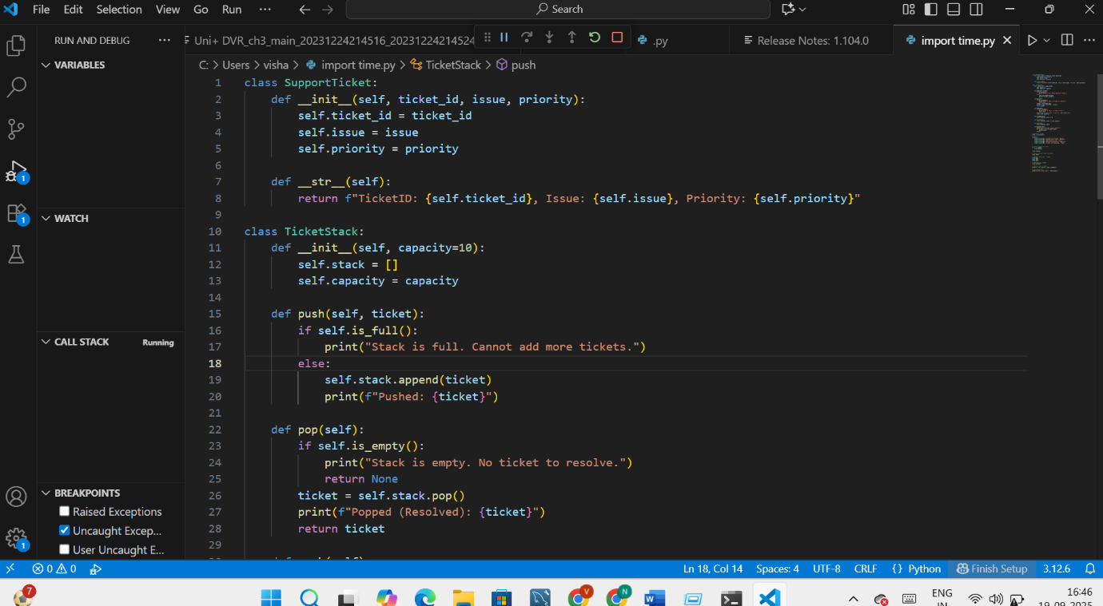

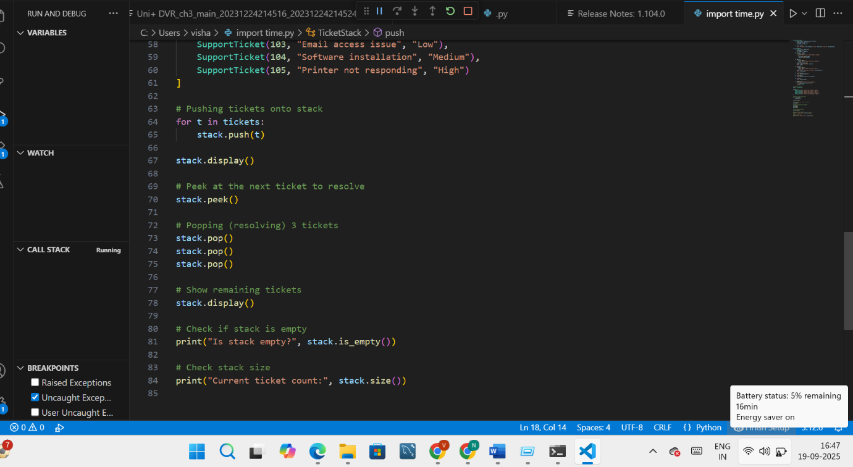

OUTPUT:

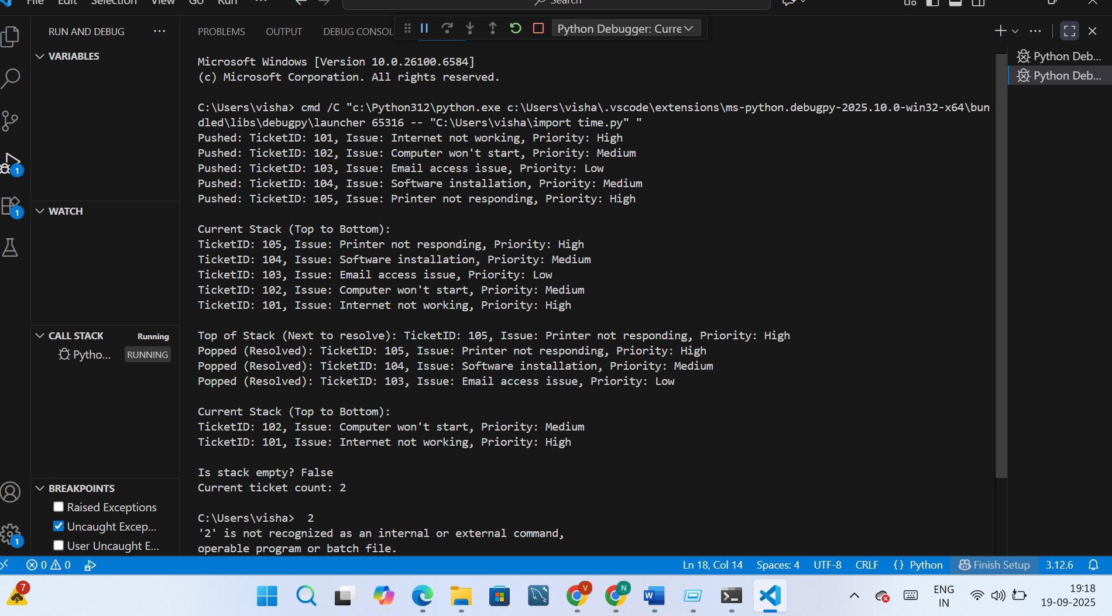

TASK 3:

PROMPT:

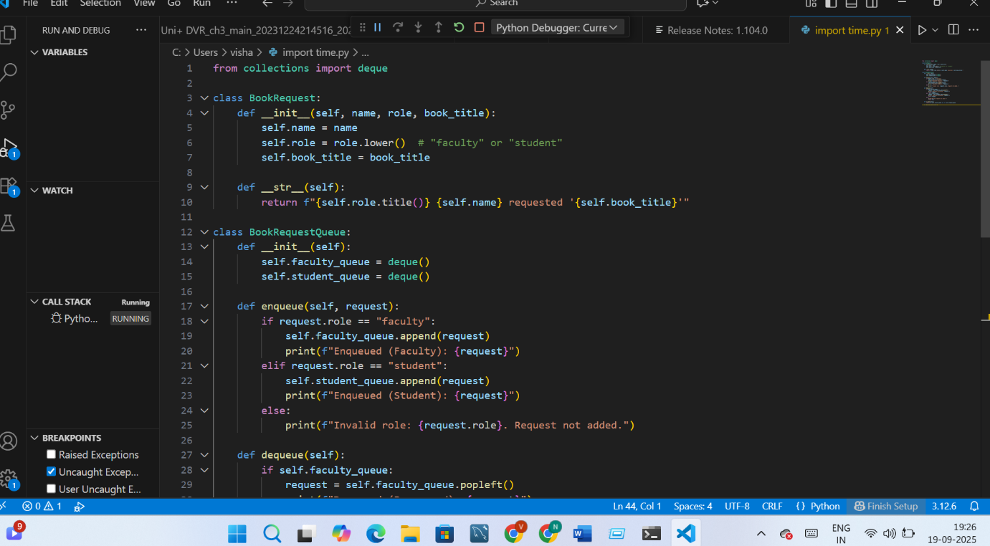

;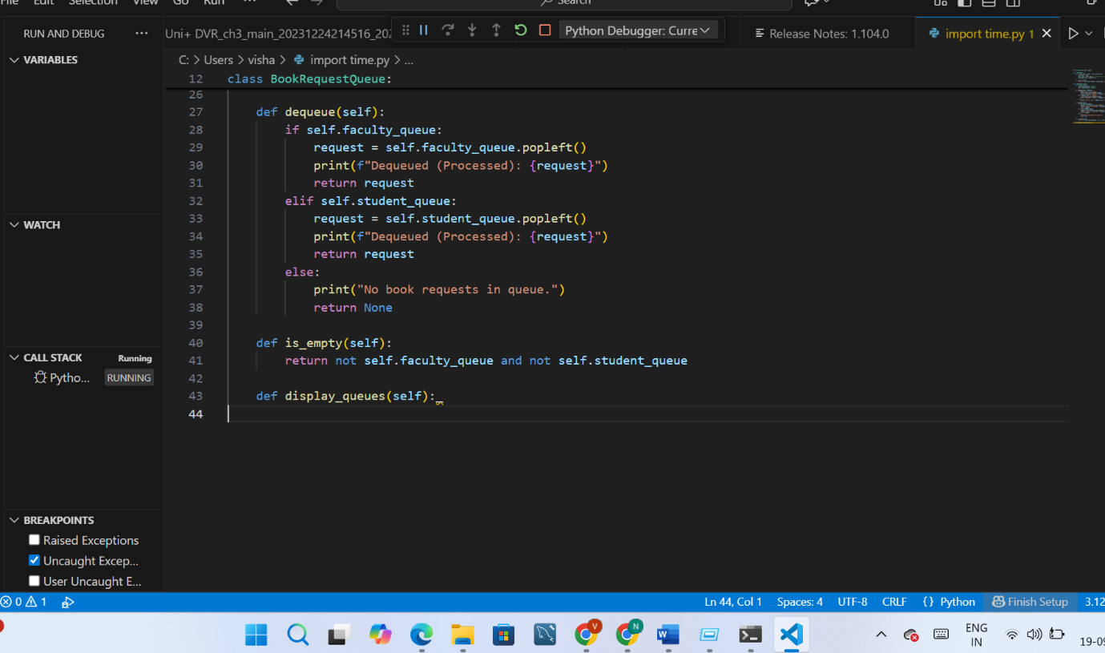

OUTPUT:

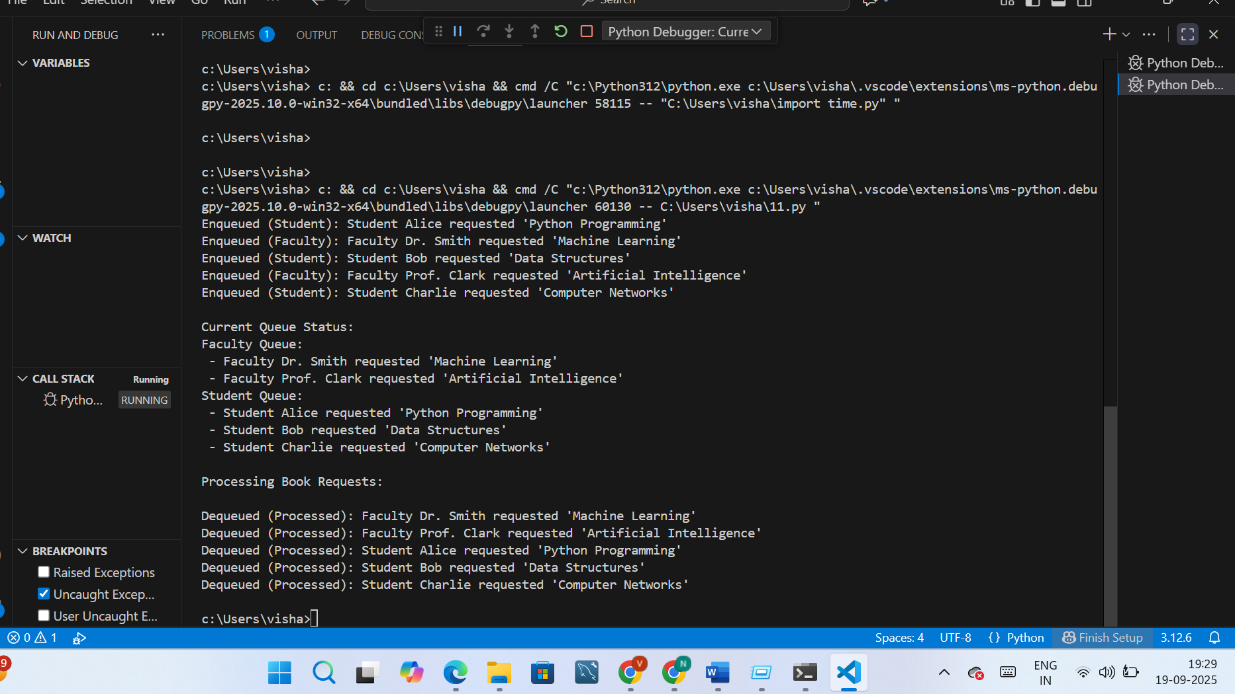

TASK:4

PROMPT:

Create a contact manager in Python that allows adding, searching, and deleting contacts (name and phone number).

First use a list (array), then implement it using a linked list for dynamic memory.

Include functions to compare insertion and deletion performance between the two.

CODE:

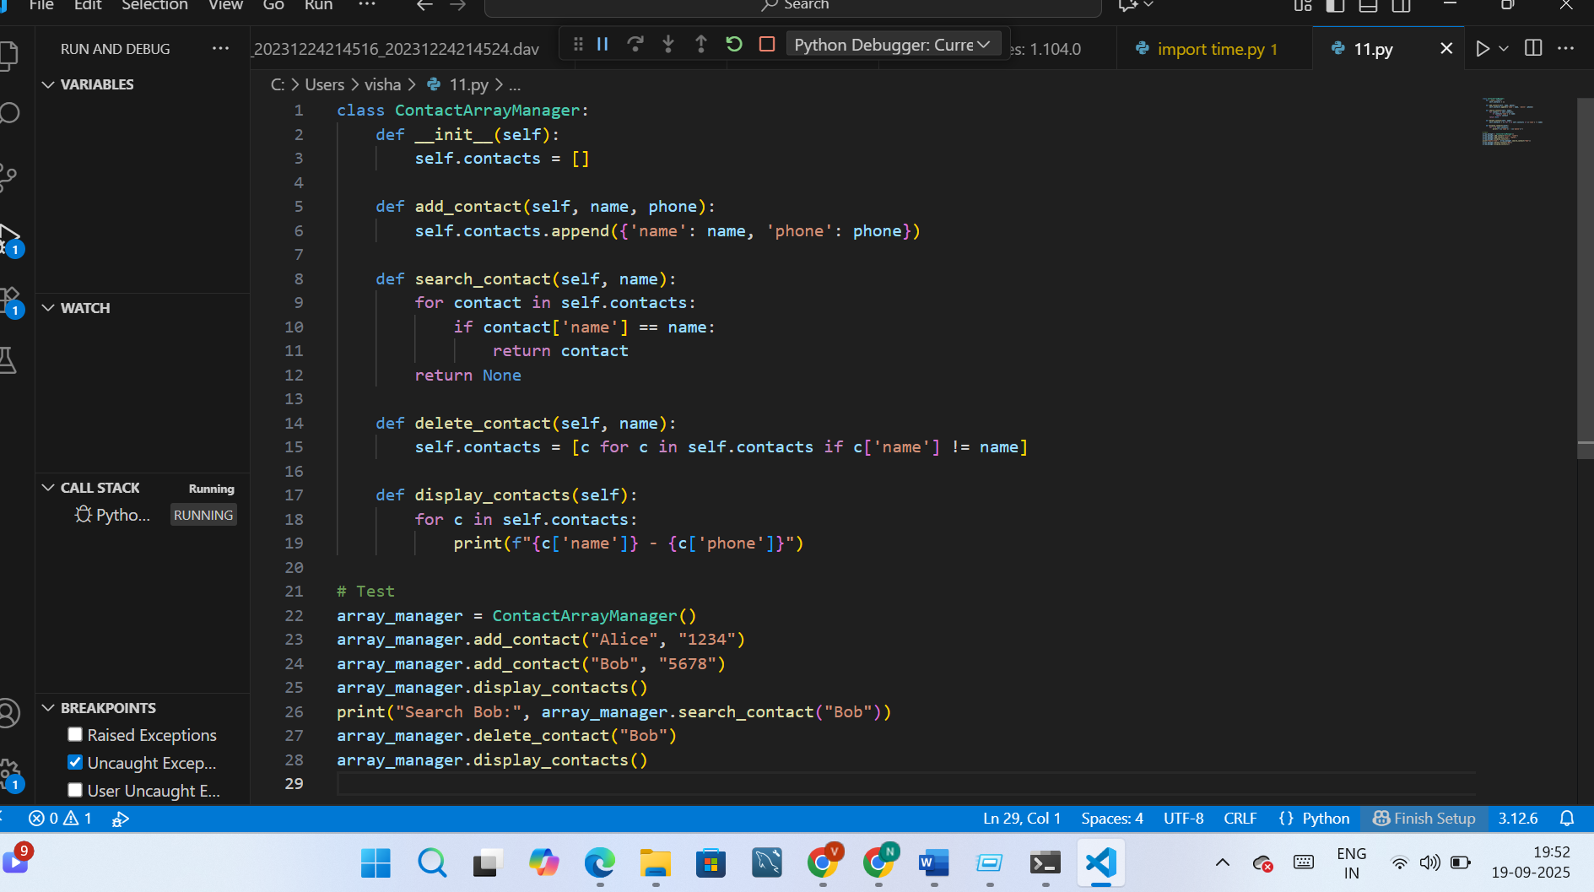

OUTPUT:

